The Mexican Tech Startup Boom
By: Héctor Beltrán, Anthropology

Cassandra Crivelli, 23, is working with her tech startup team to polish their demo pitch for Re-Active, a mobile platform that uses a smartphone to reduce chronic pain through a combination of thermo-therapy and electro-stimulation. They’ll be presenting Re-Active at the upcoming “Week of the Entrepreneur” in Mexico City, a national event aimed at bringing together Mexico’s investors, politicians, tech community, and young entrepreneurs to boost the country’s tech startup ecosystem.

Crivelli is one of many young Mexican entrepreneurs working feverishly at HUB iLab Veracruz, a technology startup incubator in Xalapa, Mexico, to develop their technology startup ideas in the hope of attracting the attention of venture capitalists or startup accelerators. Ideally, their startup idea will scale to become Mexico’s Facebook, Dropbox, or Amazon. Recent university graduates with training in engineering, design, and business brainstorm to come up with the next business technology innovation under the gaze of entrepreneurs such as Mark Zuckerberg, Steve Jobs, and Jeff Bezos, whose images and inspirational quotes decorate iLab’s walls. The playful, four-story building, complete with writeable walls where anyone can start brainstorming on a whim, opened its doors in January 2014 with tech innovation in mind. iLab was designed as a space where small teams of young entrepreneurs can quickly generate, validate, and market their tech startup ideas.

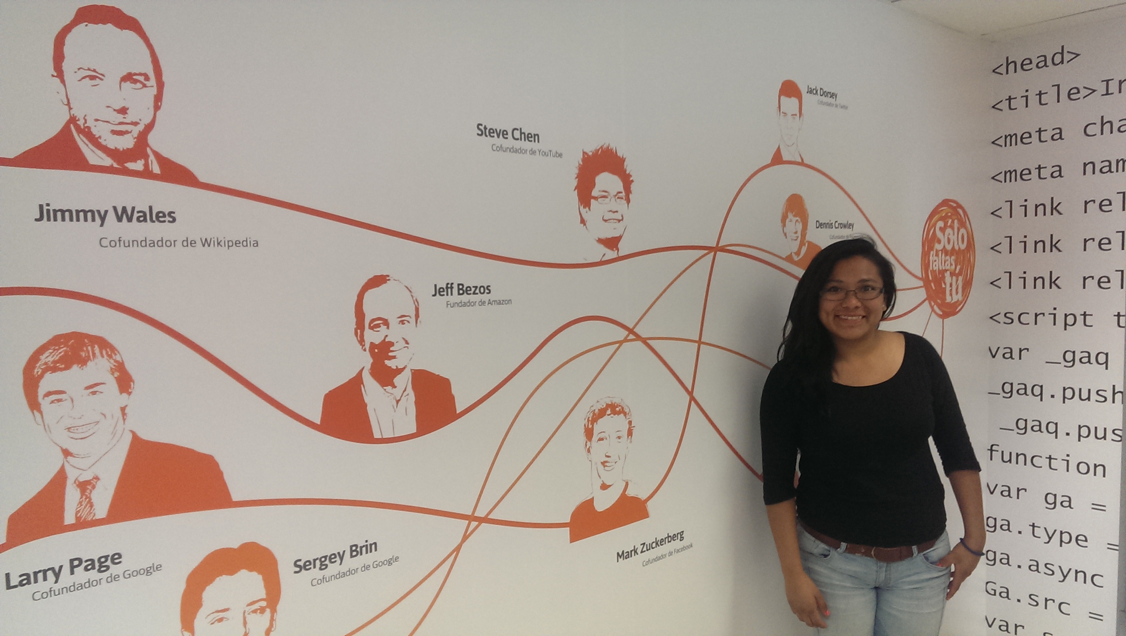

Cassandra Crivelli, 23, is part of iLab’s second cohort. One of her startups is Re-Active, a mobile platform that combines thermo-therapy and electro-stimulation to allow users to reduce chronic body pain using their smartphones. Photo by Hector Beltran.

Every cohort of 40-60 iLabers goes through a 15-week bootcamp where they study “lean” business models and the corresponding technological platforms. The goal is to create viable startup companies that solve real-world problems and have the potential to scale globally. Of the 25 startups that have emerged, 13 patents are being processed, with companies ranging from WeSee, a platform that uses a simple interface and studded cover to allow people with visual impairment to use the Android operating system; to One-T, a glove that translates hand movements into text for users learning sign-language; to SugarNut, a mobile platform where users can remotely control a peanut-shaped vibrator. iLabers are enthusiastic to tell you about their bourgeoning ideas and frequently practice their startup “pitch” with visiting academics, politicians, and other entrepreneurs.

In Mexico, the “tech startup boom” has manifested itself in the form of tech hub spaces like iLab, tech accelerators and incubators, co-working spaces, startup weekend and hackathon events, and “demo days” where young entrepreneurs pitch their ideas to a panel of judges and potential investors. Key actors certainly design these spaces and events with California’s Silicon Valley in mind as the prototypical model of innovation and disruption. However, evolving tech startup ecosystems, from Buenos Aires to Istanbul to Manila, take on divergent forms and implement different practices based on local needs, visions, and political-economic climate.

In Mexico, the tech startup scene has surfaced in parallel to hype from economic analysts that Mexico is set to emerge as the “Aztec Tiger.” President Peña Nieto’s administration has quickly orchestrated an ambitious reform agenda, addressing labor laws, tax reform, the public education system, and the telecommunications industry. Together with a last-minute labor reform from the previous administration that grants foreign corporations greater freedom to hire and fire Mexicans at low wages, enabling maquiladoras (factories that import material and equipment on duty-free and tariff-free basis for assembly, processing, or manufacturing and then exporting) to once again set up shop, critics say Peña Nieto has effectively helped to change Mexico’s image from drug war zone to free trade poster child. Mexico has 44 free trade agreements — more than any country in the world — twice as many as China and four times as many as Brazil. Peña Nieto’s reforms are aimed to move Mexico beyond low-wage factory jobs and toward an entrepreneurial economy. Mexico is producing graduates in engineering and technology at rates that challenge its international rivals, including its main trade partner, the United States. University enrollment in general has tripled in 30 years to almost 3 million students who want to join Mexico’s growing middle-class. While Mexico has become a top producer of raw engineering talent, it lags far behind in basic measures of innovation, such as number of patents, scientific papers published, and research and development investments.

Thus, iLab fits into the larger Mexican political-economic landscape as a space to keep these recent graduates busy, as a potential generator of companies that will create jobs for them and their colleagues, and as the type of institution that will help Mexico emerge on the global innovation stage. Peña Nieto’s government created the National Institute for the Entrepreneur in 2013 specifically to support entrepreneurial ventures and micro, small, and medium businesses (“MiPyMEs” in Mexico). MiPyMEs not only contribute to 52 percent of Mexico’s gross domestic product (GDP), they are the source of innovation and an axis of competitiveness for the national economy, according to Mexico’s Secretary of Economy. Indeed, government funding and interests have been a main catalyst of the “tech entrepreneurship movement” in Mexico. Not surprisingly, state government offices can be found on the first floor of iLab, and politicians frequently drop by to hear the latest startup pitches and take pictures with the teams. At the “Week of the Entrepreneur” event held in Veracruz in June, it was peculiar to see a full lineup of politicians on stage as representatives of an “entrepreneurship” event.

The political backing and presence is not lost on the young entrepreneurs. “We have to develop technological solutions to resolve mobility problems and municipal services… according to this [announcement] whether you win or not you have to submit your project, code, and documentation, and the prize is that you will appear in Xalapa’s newspaper, you get a scholarship to iLab, and you will get a pat on the back from the municipal government. Very tempting, right?” Alberto Chung Vazquez, a young man active in the Veracruz startup ecosystem, sarcastically comments on the upcoming Xalapa hackathon.

The debate about whether it is productive for government to be closely linked to entrepreneurship provokes impassioned opinions among different actors in the startup ecosystem, but the truth is that a network of private investors, whether domestic or foreign, has not yet emerged to support Mexican startups. “Angel” investing in the Silicon Valley, for example, has become popular to the point of being sexy, as wealthy investors, many of whom made their fortune during the dot-com bubble, revel in the rush of investing in early-stage tech startups. In my interviews with entrepreneurs, investors, and startup event coordinators, one salient theme was that Mexico lacks the “culture of risk” present in places like Silicon Valley. This was but one of the cultural dimensions respondents identified as missing elements in the Mexico startup scene. Almost unanimously, respondents said that Mexico’s school systems teaches students to be employees and not to be their own bosses.

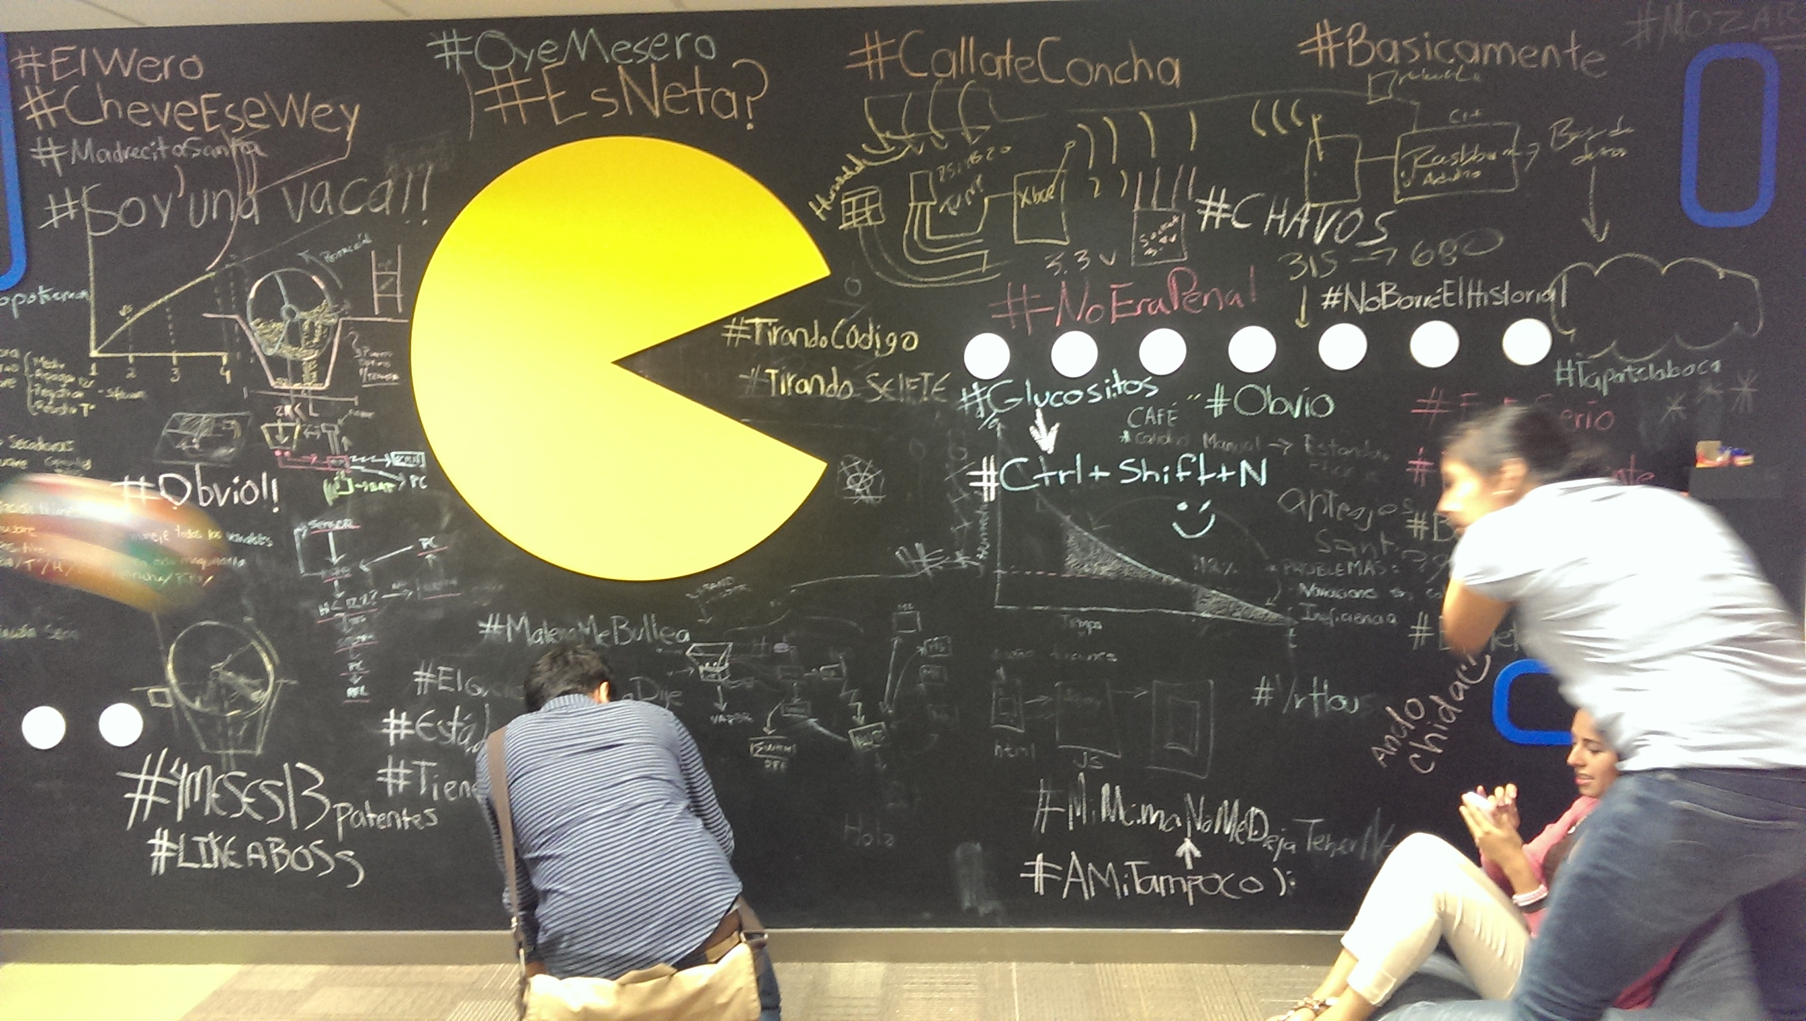
Entrepreneurs-in-training participate in a bootcamp-style tech entrepreneurship program, sponsored by M.I.T., iLab, and the Universidad Anáhuac. Photo by Hector Beltran.

Juan Pablo Cappello, a Chilean-born journalist who writes about Latin American startups and has started about two dozen himself, claims that after years of trying to create “clones” of U.S. startups (e.g. Uber, Twitter, Groupon), Latin American startups have been un-inspirational precisely because the ecosystem has supported these “bakers”: hard-workers that get up early, work hard, and gather the necessary ingredients to make the bread. What is different in Silicon Valley, he says, is that there they invest not in the bakers but in the artists, the inspirational visionaries that create disruptive tech companies. iLab sees itself as fundamental to transforming the cultural values and attitudes of iLabers into dispositions that can foment this missing culture of disruption.

iLab makes an effort to recruit diverse students, in regard to disciplinary, socio-economic, and racial-ethnic background, with the hope that they might attract the artist/visionaries/entrepreneurs Cappello refers to. Such is the case of Daniela Rivero Rodriguez, a visual artist by training and the creative force behind four of iLab’s startups, including WeSee and SugarNut. “I didn’t know anything about technology. I didn’t know anything about business either. The first months it was very difficult to understand all of this. Artists are somewhat proud/arrogant. We do our work, and we don’t care if people understand us….Before I saw art everywhere, and now I see apps and technological projects everywhere that can improve anything. The most important thing I take is the teamwork necessary for these projects. It’s very important for the development of our country.” Rivero Rodriguez is the guest of honor, the only young person and the only woman in a panel of 11 speaking at the inaugural ceremony at the Week of the Entrepreneur in Mexico City.

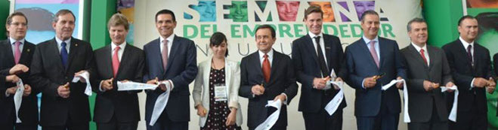
Daniela Rivero Rodriguez, 27, is the guest of honor in Mexico City’s Week of the Entrepreneur, an event sponsored by the Institute for the Entrepreneur. Photo from Secretary of Economy site (http://www.economia.gob.mx/).

That Rivero Rodriguez is the only woman on the panel and one of the few women involved in the tech startup scene is not irrelevant information. At this year’s Mexico Campus Party, an event focused on technology held in Guadalajara, a company’s model-aide sported a QR code on her buttocks that participants had to scan to access a promotion. The incident resulted in the company coming under fire, and debate erupted amongst activists and tech enthusiasts related to gender equality in the tech scene. On the other side of the border, California’s Silicon Valley has recently come under attack not only for the lack of representation of women, but also for the lack of representation of racial minorities after companies like Twitter and Facebook released their diversity reports. Moreover, community organizations have been actively organizing against the gentrification and increasing social inequality the tech startup boom has brought to the Bay Area, with the term “techie” now evoking negative connotations.

Thus, as the Aztec Tiger roars (or whimpers), and its middle-class continues to attract media attention, it will be interesting to see how the tech startup boom is implicated (or implicates itself) in relation to issues of socio-economic inequality. According to Forbes, 15 of Latin America’s billionaires are from Mexico, and while three-quarters of the residents of Mexico’s countryside have sub-middle class income levels, three out of the five wealthiest individuals in Latin America are from Mexico. Victor Moctezuma, director of iLab, tells me, “Lean means slim, but it also means we are always in beta. Nothing is certain. All the time we are re-formulating everything. Sometimes this can be an addiction and sometimes a virtue. If we see something is not being applied correctly we calibrate it. If we see there is a process being applied successfully in another location we adopt it and connect it to ours. We don’t want to be static, we want to be very dynamic.” Moctezuma’s vision for iLab certainly takes into account the agility and ephemerality that has come to characterize the Silicon Valley, attributes said to spur its competition and innovation. As more iLabs continue to emerge and Mexico’s tech startup boom continues to develop, we should focus on how some of the problematic dynamics that have also come to define the Silicon Valley are adopted, ignored, and/or re-formulated in Mexico.

