The Challenges of Mexican Elections
By Christopher Carter

Antonio Manuel López Obrador (AMLO) has been one of the most frequent critics of Mexican electoral politics. The two-time presidential candidate for the left-leaning Party of the Democratic Revolution (PRD) challenged both elections that he lost. He maintains that the elections were “plagued with irregularities.” To some, AMLO’s critiques and challenges are simply a manifestation of a reluctance to lose an election. After all, he challenged when losing by both small (2006) and large (2012) margins. Others, however, have taken AMLO’s charges more seriously, agreeing that electoral fraud continues to be a major concern in Mexican electoral politics.

Regardless of their justifiability, López Obrador’s decisions to challenge are emblematic of a larger trend in Mexican politics. Challenges to electoral results have risen markedly over the past three presidential elections. In 2000, only two petitions of dissent were filed with the Mexican electoral tribunal. This number rose to 377 in 2012.
The decision to challenge is not limited to a particular party either. Challenge petitions were distributed roughly equally among all three major political parties —the PRD, the Institutional Revolutionary Party (PRI), and the National Action Party (PAN). The success of these challenges, however, has been relatively limited, with most results being upheld by the federal electoral tribunal.

Why, then, do candidates decide to challenge when the chances of victory are so small? One explanation is that it is an attempt to delegitimize the incumbent. As one PRD official said, “[Losing candidates] lose because they don’t have votes. If they can’t get the votes, the best strategy is to make the winner look bad. Then, maybe you win next time.” By challenging elections, losing candidates can assert that fraud was present. By linking the winning candidate to corruption, losing candidates may decrease support for the victor and increase their chances of victory in the next election.

Another possibility is that challenges are an attempt to keep support mobilized. By failing to accept the outcomes of elections, candidates have the opportunity to rally their supporters around a common claim of unfairness. This may serve to increase the candidates’ chances in future elections. A third motive may be to increase a personal support base to further enhance the politician’s position within his/her own party. If a challenge boosts a politician’s notoriety and creates a stronger voice among his/her supporters, there is a strong chance that the politicians’ party will take notice. In a context of powerful parties, like Mexico, getting the party’s attention is extremely important for ambitious politicians.

Of course, the likelihood that a politician will admit to these self-serving goals is relatively low. Every losing candidate claims that fraud is the main reason why a challenge is launched. Ultimately, however, the chances of overturning a result are statistically very small. Close elections are also no more likely to be challenged than elections won by a wide margin. Thus, it stands to reason that there must be some alternative benefit to challenging elections independent of the success of the challenge. Interviews with a variety of politicians suggest that there is a self-interested motive to the decision to challenge. An intrinsic benefit from speaking against democracy appears to be only minimally important.

Whether or not the contestation of electoral results is justified, the rising number of challenges offers fundamental insight into problems of democratic competition in Mexico. If the challenges are justified, electoral fraud continues to mar Mexican politics. If the challenges are not justified, then the failure of candidates to accept electoral results signals one of two possibilities: declining respect for institutions or the manipulation of institutions for personal gain. In any case, the manipulation of election results appears to have strong implications for the quality and legitimacy of Mexican electoral politics. Mexico is no longer ruled by a single party, but concerns over the quality of democratic competition remain.

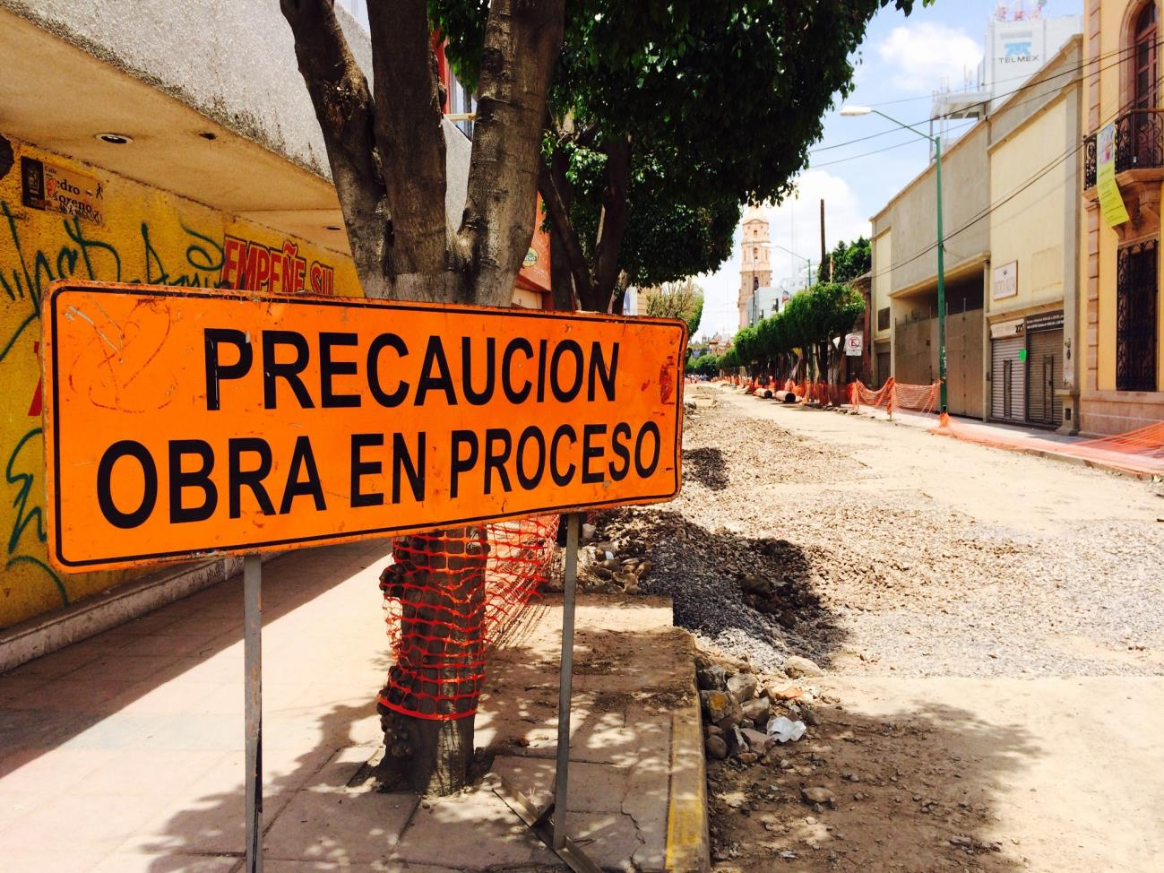
Electoral challenges illustrate that Mexican democracy remains very much a work in progress. León, Mexico
Carter 4
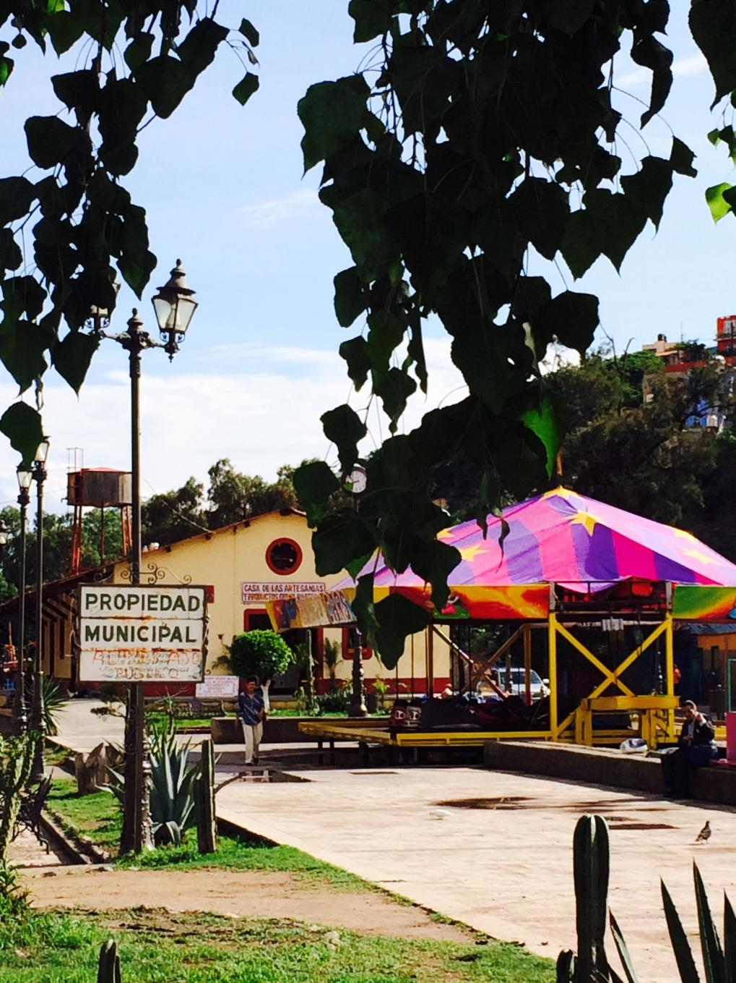
Challenges occur not just at the federal level but also at the municipal level. Guanajuato, Mexico

