How did a prehispanic workshop look? The study of stone tool production and daily life at a Mayan archaeological site during the Late Classic (700-900 CE).

There are different ways of getting to know the past and how people lived in ancient times. In the case of Mayan studies, we have a plethora of analyses and interpretations that delve into the upper strata of society plus a vast collection of archaeological artefacts and monuments preserved that aid in the study of the past. Much of Mayan archaeology has been carried out in the major population nodes, where the arts, writing, and high culture were part of the elite discourse and encompasses a large part of archaeological knowledge. Recent archaeological research in the Northwestern Maya Lowlands has taken a more expansive focus: understanding how ordinary, non-elite people lived in the past. My research focuses on rural domestic contexts at the site of Chinikihá to understand how people lived in the site and interacted within the region. This archaeological site was occupied during the time period known as the Classic in Maya (300-900 CE).
My Ph.D. dissertation looks at local practices, domestic activities, economy and exchange. By examining domestic activities, we can observe the most intimate and basic level of human interaction and social patterns. The study of domestic activities is the study of the home, the household, and the family. This research will aim to uncover what people did in their place of dwelling, what they ate, and what types of activities they carried out on a day-to-day basis. Not only are we going to look at the houses and surrounding areas, we are also going to study the places where they worked, made their tools, and applied the local technologies as a way of life. We also intend to continue the study of communication routes as they can help us understand exchange and economy. Through this kind of study we can reconstruct contact or social relations between people at the local, regional, and long-distance level.
I have been working on an archaeological project sponsored by the UNAM (National Autonomous University of Mexico) with collaboration with UC Berkeley and Rhodes College. The archeological project pools the talents of different specialists to research various aspects of the site. Another highlight of this year was the presence of two great undergraduate UCB students who experienced their first field season in Mexico.
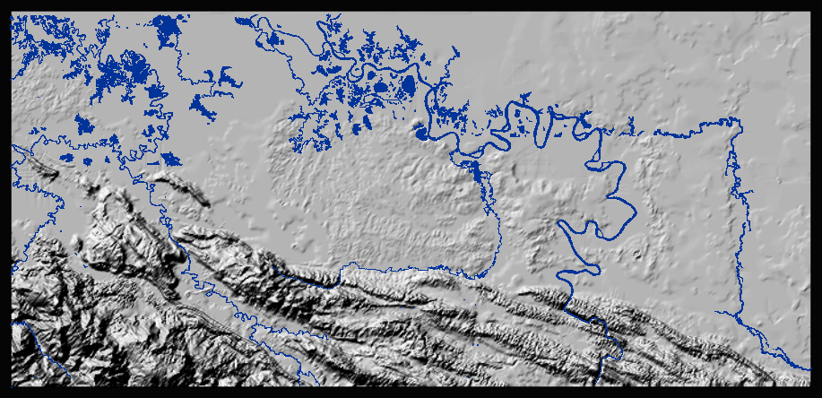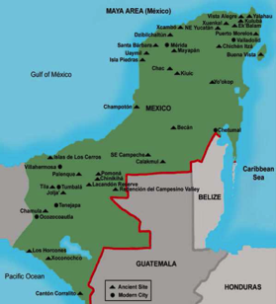

Figure 1 Map showing the study area and topography: F.G. Silva and E. Miron IIA-PRACH-UNAM
The site of Chinikihá is located in close proximity to better known and bigger archaeological sites such as Pomona, Yaxchilán, Bonampak, Comalcalco, Reforma Morales, Piedras Negras, and Palenque. It is located at a strategic point between the site of Palenque and the Usumacinta River, one of the main transportation arteries in the area (see map). It was a local node of population and was part of the Classic Maya culture that included epigraphy, monumental architecture, and a ruling elite with high-ranking political titles.
As we currently know, Palenque was the main urban center of greater political and economic influence in the region. Yet Chinikihá was an important center of political and economic influence in the surrounding area, as there are known monuments that describe important locals with political titles as well as being part of the conflictive culture of the time. As an example, there is an epigraphic description, or Maya writing, of the capture of a military leader from neighboring and important political center of Pomona by a member of the ruling family of Chinikihá.
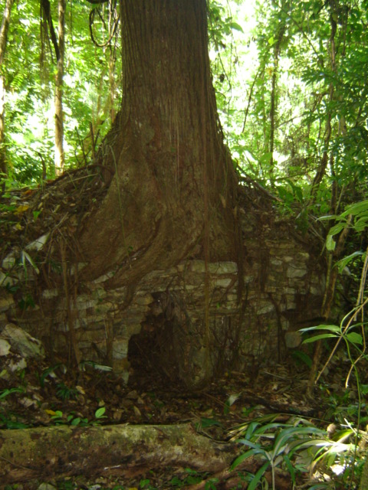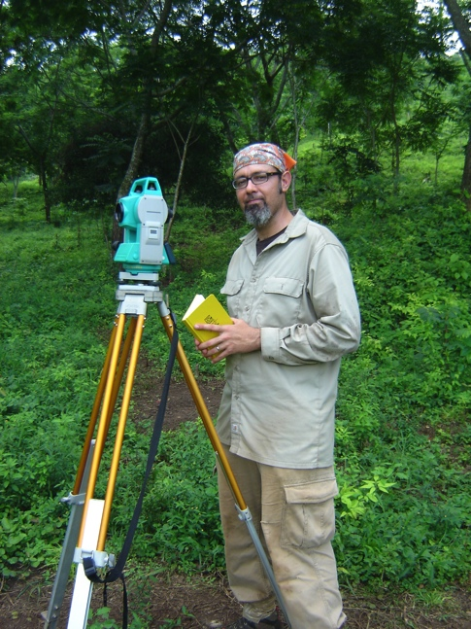
Figure 2 Image of a building at the site and the author: image F.G. Silva
The area we commonly refer to as the Maya area, was part of prehispanic Mesoamerica. This is important to remember because this is related to the complexity of contacts in the ancient Americas. The term Mesoamerica was first coined by historian Paul Kirchhoff in an attempt to define the cultural zone where different indigenous groups lived and developed unique civilizations that shared certain traits such as writing, time keeping, architecture and urbanism. The geographic area encompassed by the term Mesoamerica includes, but is not limited to, the countries of Mexico, Guatemala, Honduras, Belize, and El Salvador. The term also includes many diverse cultures that existed in the area at different times, including groups known today as Olmecs, Mixtexs, Zapotecs, Popochtlas, Mexicas, and Mayans. The Maya were part of the way of living of Mesoamerican people that included social relationships reflected through exchange and movement of people through this vast territory.
As other Mesoamerican cultures, the Maya left us with lots of artworks and iconography where different events have been depicted and provide us with an amazing point of reference. This images have to be considered within their context, as they tend to depict individuals from ruling families in scenes of palaces, yet I think provide us with a unique opportunity to look at every day life. A great place to observe images of architectural spaces such as palaces is the codice vases. These vases are unique artifacts, made as gifts or to commemorate special occasions, yet we may observe social events where we might see a palace scene with a ruler sitting on a throne leaning on a cushion, curtains, pyrite mirrors, trumpets playing music, drinking vessels, and individuals hanging out talking (observe Kerr vase K1453).
Or we might see an image of a meeting between individuals negotiating that was commemorated on a vase that allows us to observe plates, mirrors, fans, bags with beans, cloths or mantas, salt, as well as people talking (observe Kerr vase K2914). Other samples provide us with the image of a woman using a metate (flat stone for grinding) and a grinding stone or mano while a male watches her while he smokes a cigarette (as in Kerr vase K1272). Let’s think of the intricate and complex level of exchange and economic flow that was part of ancient Mesoamerica, and the Maya area was no stranger to such economic web. We might ask ourselves if we can know that level of detail, and this study will give us a chance to study domestic contexts from non-elite groups at Chinikihá as well as their areas of work. I mention these vases as iconographic images of activities within architectural spaces, perhaps even domestic spaces in some instances.
Within the site of Chinikihá we have located an architectural group that has well-defined activity areas and a dwelling or household group, which is where I am concentrating all of my efforts and excavations to better understand questions related to domestic activities, production, exchange, and economy during the Late Classic (700-900 CE).
For my Ph.D. dissertation I am studying the local production of stone tools or lithic artefacts by excavating different areas of an architectural group. As mentioned briefly before, we have localized an architectural group with a domestic area and an activity or workshop space where they were producing stone tools. This specialized area is unique in the sense that we can study the area where people dwelled or lived as well as the area where they worked. The information recovered during this past field season was vital in understanding the differences in use of space within the architectural group. By excavating an area we recover artefacts that help us understand what people did in the past and how they lived. It can be seen as detective work; we find certain clues that help us reconstruct past living surfaces, what people ate, even where certain artefacts came from. This last one is important since we can understand economy and exchange. As an example, we are carrying a study on the obsidian found at Chinikihá doing a sourcing analysis through a technique with EDXRF (Energy Dispersive X-Ray Fluorescence). This is an analytical technique used to obtain the chemical characterization or elemental analysis of obsidian. Obsidian is a natural volcanic glass that is formed as an extrusive igneous rock in a single moment of eruption, giving each obsidian source a type of elemental fingerprint. Through this analysis we can know where the source of that specific artifact is located and reconstruct exchange routes and provenience of raw material. We have sourced obsidian to places as far as the center of Mexico, to a source located in Pachuca, Hidalgo, but most of it comes from el Chayal in the highlands of Guatemala.
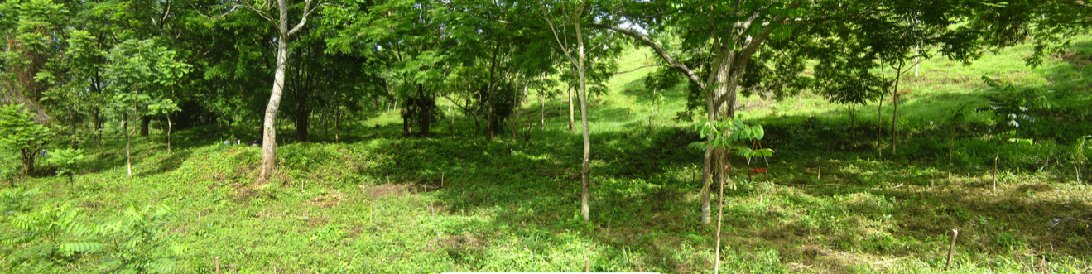
Figure 3 Image of G-13 and G-16 taken from the SE portion of the group: image F.G. Silva
This study is beginning to take form, and we are only starting to see how this part of the site was utilized in ancient times. Yet, the information recovered during this season is already helping us understand some of the possible activities taking place at the site and its relationship with the surrounding sites. We are beginning to see the different types of stone tool artefacts and type of technology utilized in the area. My trip included a short trip to Mexico City at the end of the season to return all the equipment to UNAM. Even though it was only a few days, it gave me a chance to go over some of the material and with the help of the UCB undergraduate students, get an initial idea through the ceramics of the chronology or time period, as well as the types of ceramic ware used in the architectural group. I am currently getting ready to go back to the field in another month and continue the excavations and research of domestic or household archaeology at Chinikihá.

