**An Opportunity to Include *People* in Nicaragua’s Low Carbon Energy Transition**

Diego Ponce de Leon Barido

The suffocating summer heat of Managua slaps you in the face as soon as you step off the plane. At immigration, cold air is blasting from refrigerator-sized AC machines, and you pay your 10 bucks to the officer, earning you a visa to once again enter the sweat-drenched sauna you just arrived into. Outside, taxi drivers swat your luggage off your hands while pushing you into their taxis, and at your hotel, or wherever you are staying, your room will likely have a blasting AC or a fan that will prevent you from spontaneous combustion during the night. It’s only 10:00 pm, and the sun is down, but you already dread the come of dawn and the pulsating heat emanating from Managua’s concrete streets.

Overall, things in Nicaragua have been getting better. While it’s northern neighbors have been plagued with gang related violence for the last five years, Nicaragua has remained relatively calm — and more recently undergone a renewable energy revolution. It’s deforestation rates are relatively low — 1.3 percent compared to some of the worst spots in the region (averaging 5 percent) — and in 2012 it inaugurated an “ecological battalion” in charge of monitoring deforestation in the Atlantic forest.1,2,3 In contrast to its Central American neighbors, where gangs and drug traffickers have overwhelmed capital cities, drug trafficking here has largely stayed on the Atlantic Coast, where some of the bounty from white lobster (cocaine) is shared with fishing villages and coastal Caribbean communities. Drug addiction, however, has begun to be a major regional problem. I’m here to study energy, though, a sector where Nicaragua has recently had major progress, and I dive in as soon as I wake up the next morning.

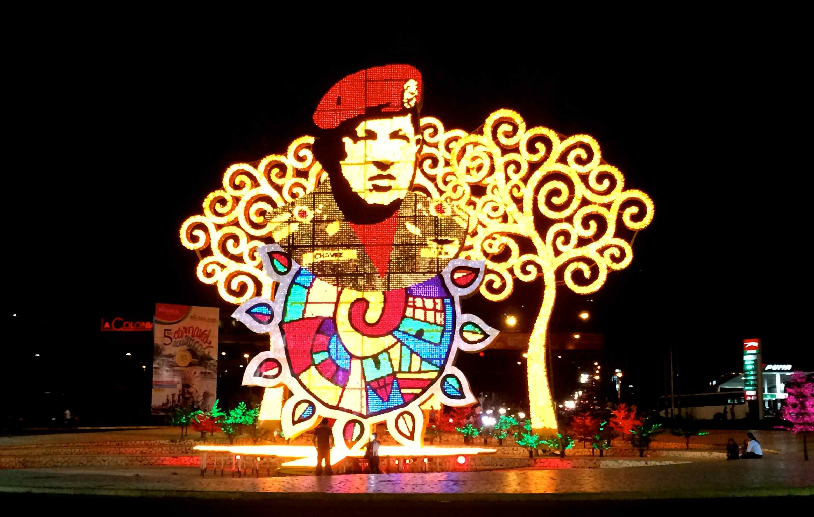

*Fig 1. Oil Diplomacy in Nicaragua (Picture: An image of Hugo Chavez in “la rotunda Hugo Chavez,” one of Managua’s most visited streets and avenues)*.

Since the early 1960s, the United States, the Soviet Union (later, Russia), Mexico, and Venezuela have exerted different forms of oil diplomacy in Nicaragua. Oil aid, petrodollars, and other hydrocarbon-related infrastructure have created a large sense of dependency on foreign aid and allowed for political intervention. Oil accounts for over 80 percent of all energy imports, and over 55 percent of Nicaragua’s revenue from exports goes towards covering this expenditure.

Although part of my summer research was to investigate the potential for a microgrid project for the Wawashang agro-forestry center on Nicaragua’s Atlantic Coast, my contacts there cancelled my visit. As I traveled through the country, however, and understood more about Nicaragua’s problems, I realized that the capital city had enough interesting questions for me to begin addressing during the summer. With Nicaragua becoming increasingly urban, and with great progress towards electricity access (currently 80 percent), one could argue that urban grid management will be one of the country’s most pressing energy challenges during the next 30 years.

As I drove through the city in taxis and buses, and walked through Managua, the city’s heat overwhelmed me. I wondered: *How does the heat affect energy consumption and the lives of the urban lower-middle class? How are Nicaraguan’s benefitting from the clean energy revolution that is transforming the country’s energy matrix? Do large-scale renewable energy projects also bring about positive social transformation? And, how can we ensure that the benefits of a low-carbon energy transition can empower the urban lower-middle class in emerging economies?*

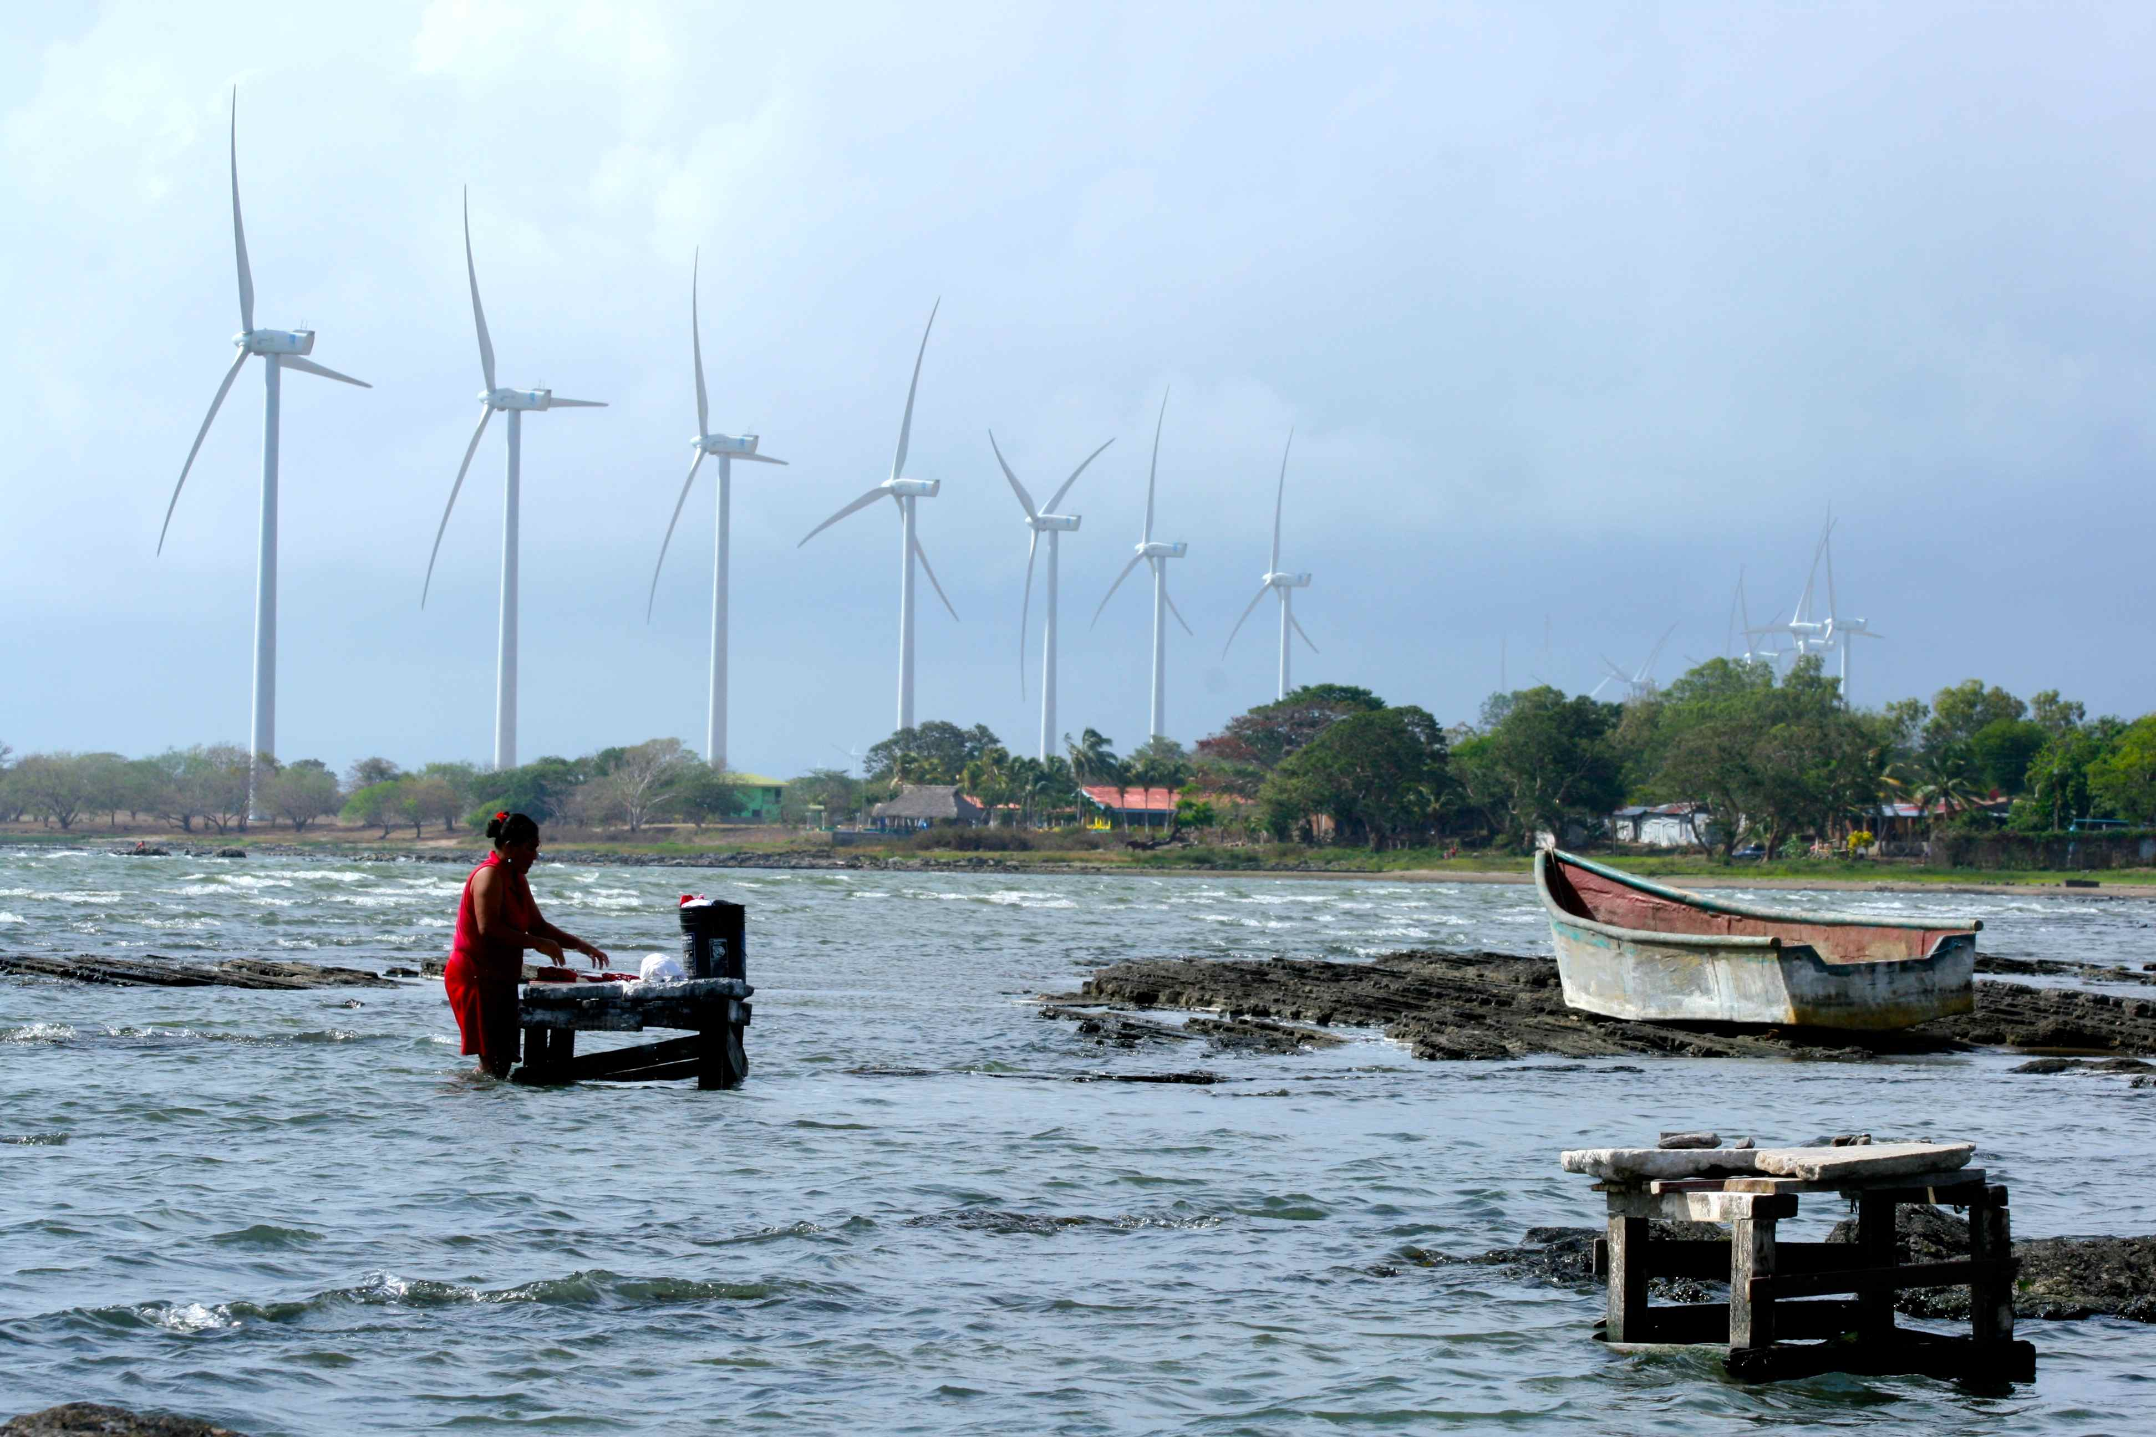

*Fig 2. People and Power.* *A woman washes her clothes in Lake Nicaragua, as wind park Amayo (40 MW) blows in the background. Although Nicaragua has a vibrant off-grid electricity community, it is not yet clear whether large-scale renewable energy projects have benefitted Nicaragua’s population.*

In the last five years (2009-2014), Nicaragua has: installed approximately 190MW of wind energy capacity (14 percent of total installed capacity), undergone intensive geothermal technical capacity training in partnership with Iceland, and received $US 292 million in new clean energy investments. Between 2006 and 2012 the country received $1.5 billion in cumulative renewable energy investments (5 percent of GDP). Yet despite this great progress, the country’s ambitious renewable energy policy goals (79 percent and 93 percent renewables by 2017 and 2026 respectively) seem daunting. Results from our summer renewable energy modeling efforts, the first to have been done in the country, using SWITCH–Nicaragua (in partnership with Nicaragua’s National Engineering University) suggest that by 2030 Nicaragua could provide over 50 percent of its generation from renewable energy generation (excluding large-hydropower).

SWITCH’s base cost scenario gave us a least-cost energy system that obtained 40 percent of its power from distillate fuel oil in the first investment period (2014-2017), and only 20 percent, 6 percent, and 4 percent in the subsequent time periods (Figure 3). The role that bunker fuel oil plants play in the Nicaraguan energy system will likely also change over time from being the main system generator to merely operating as peaker plants, which would provide system flexibility and help meet planning and quick-start capacity reserves. Less money will also be spent on bunker fuel oil over time — during the final investment period (2026-2029) the model predicted that Nicaragua would spend approximately $US350 million on fuel oil (compared to $US2 billion in the first time period). To contextualize the magnitude of these costs it is worth noting that Nicaragua’s GDP was roughly $US11 billion in 2013.



*Figure 3. Base cost scenario cumulative new capacity additions [A] and percentage of generation mix by resource and investment period [B]. During the summer (results forthcoming) our modeling efforts incorporated a national renewable portfolio standard, placed moratoriums on distillate fuel oil consumption and large hydro development, and implemented geothermal and solar mandates.*

With Nicaragua already moving towards a low-carbon future, more efficient and reliable integration presents an even greater challenge. While our modeling efforts have helped us explore utility grid deployment scenarios for different combinations of renewable energy technologies, thinking about how these technologies will be integrated into the existing infrastructure (residential, buildings, industry, and transport) presents a great opportunity for other types of more applied research, technology deployment, and innovative business models. Although demand response covers a wide range of actions, Nicaragua’s residential load curve and a growing manufacturing industry could allow for earlier adoption of demand response strategies into a variety of consumption patterns and engineering processes. It could help avoid future installed capacity costs, contribute to peak shaving, and reduce the need for contingency and regulatory reserves. Due to the paucity of information about demand response strategies in emerging countries — and to its large potential — this is where I focused my attention for the second part of my summer project.

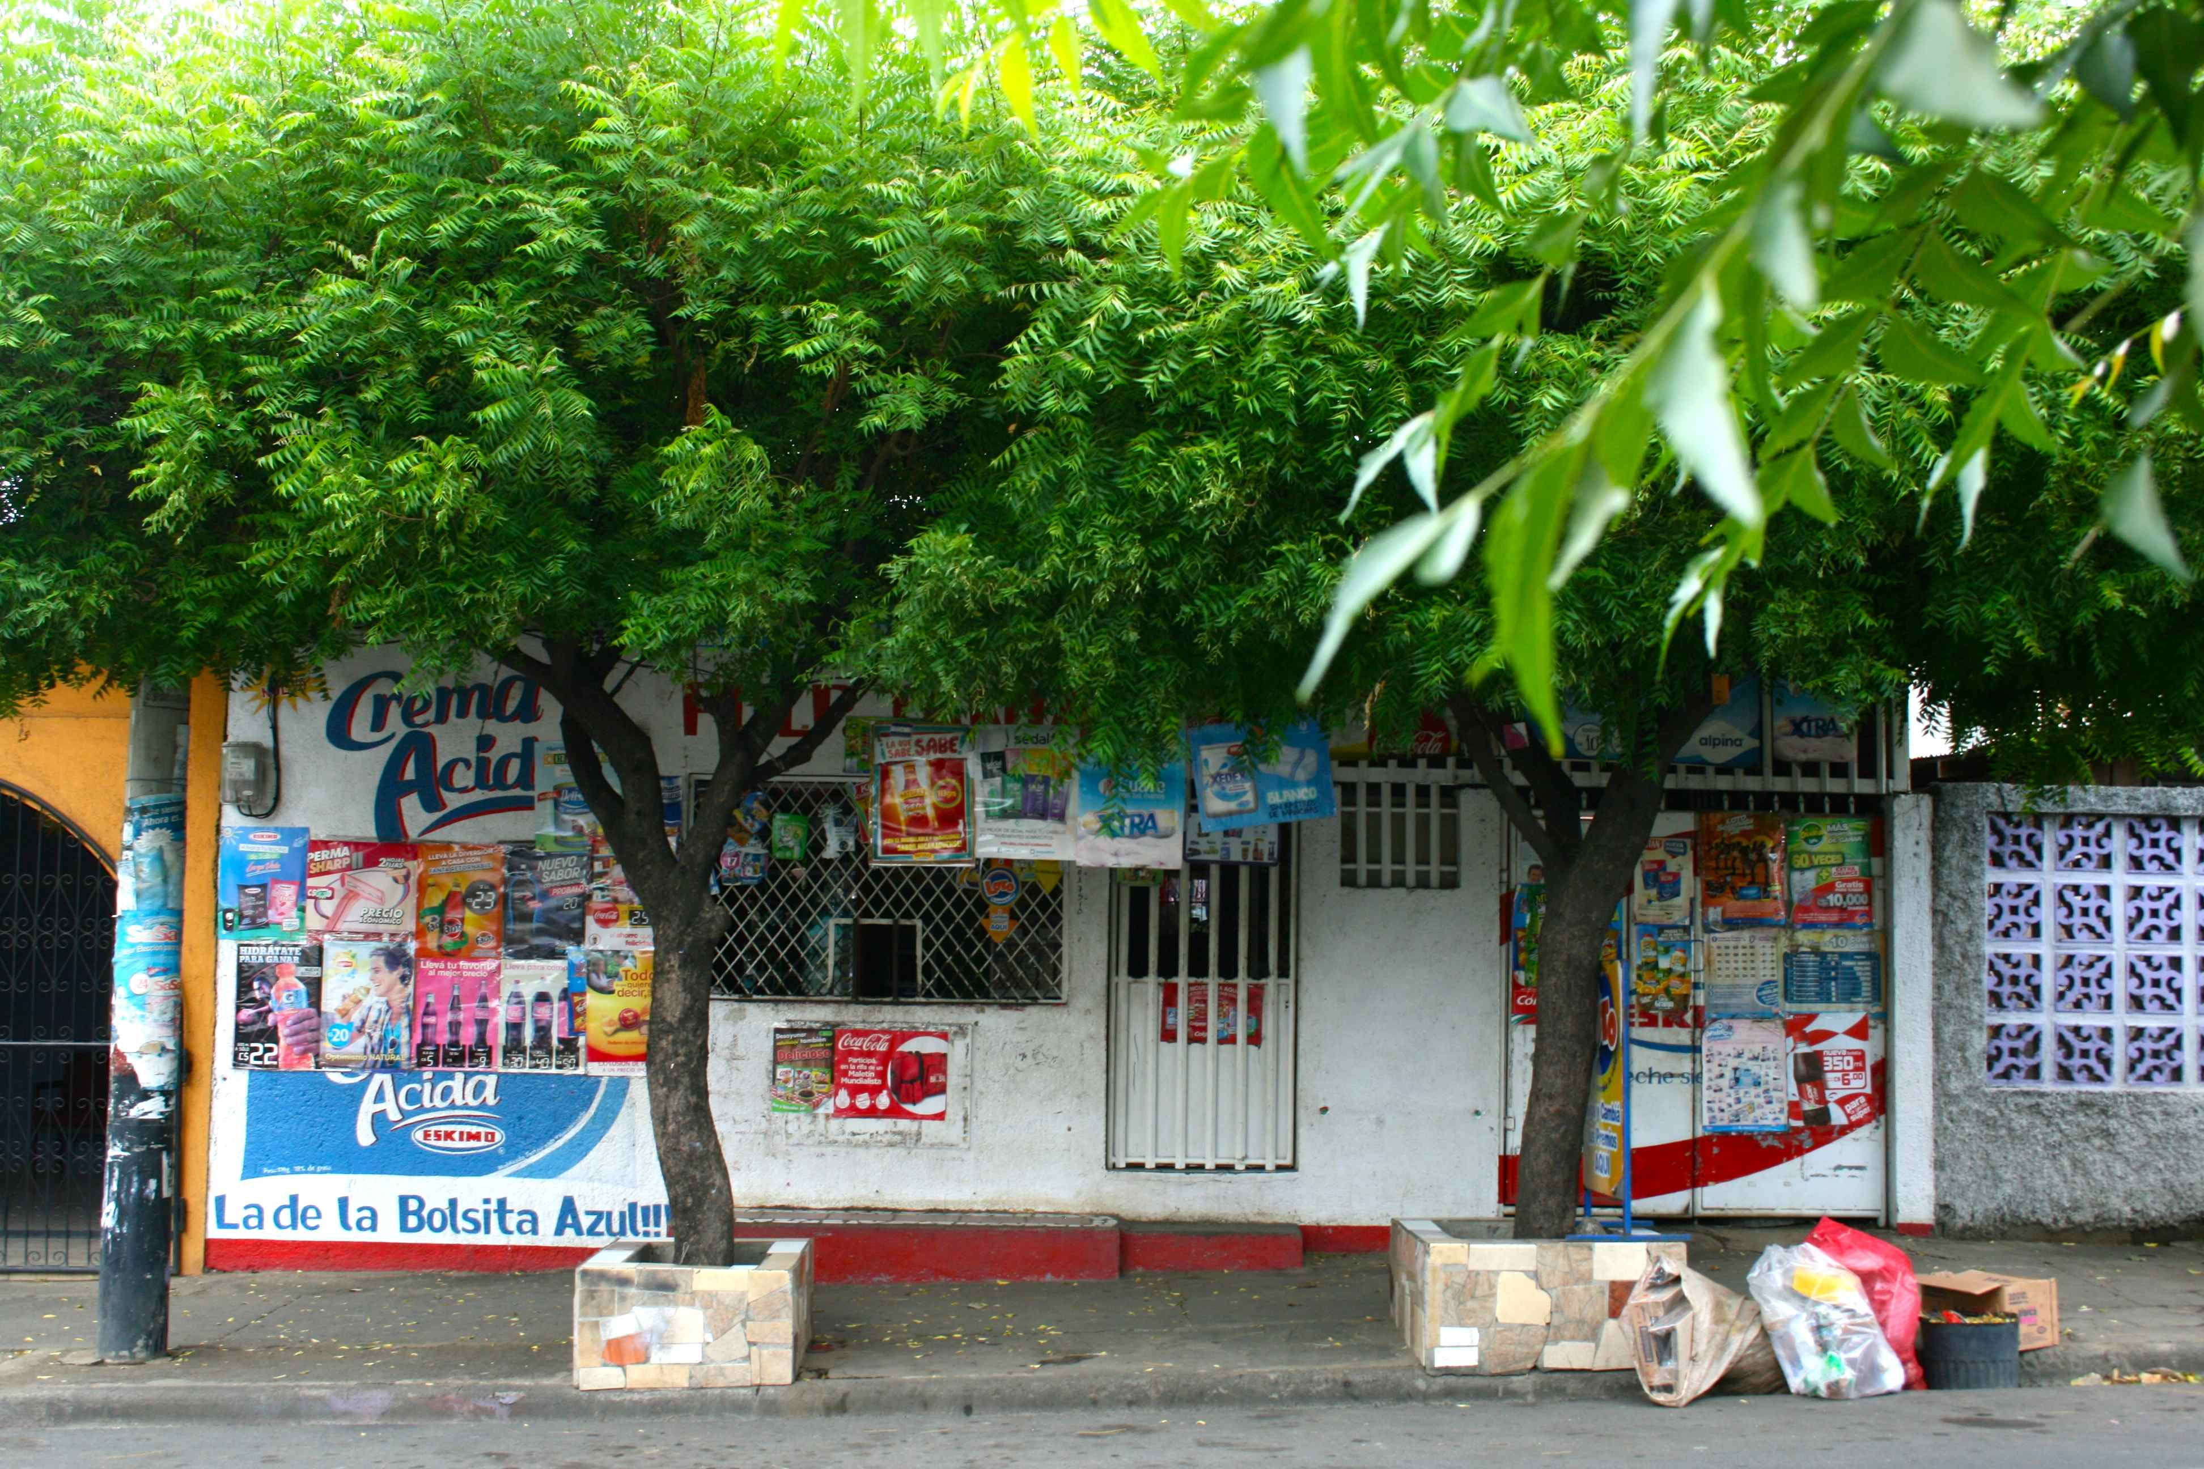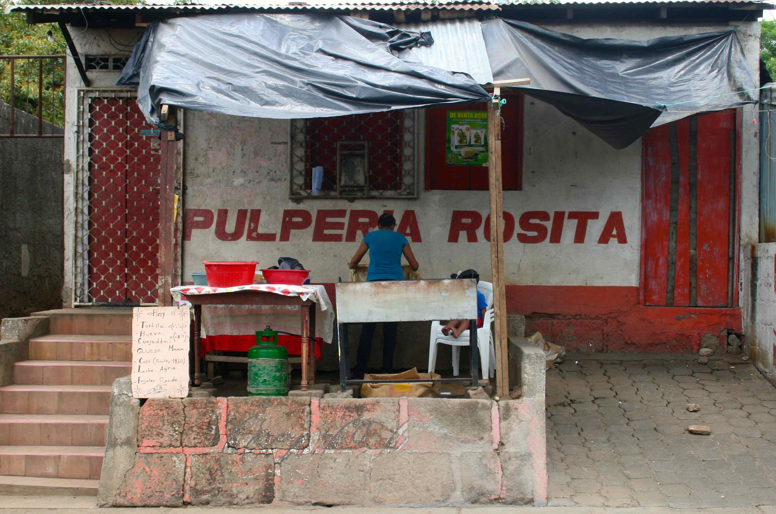

*Figure 4. High Energy Costs and Micro-Enterprises:* Despite the low-carbon energy transition that Nicaragua has recently experienced, micro-enterprises in Managua claim that their largest operational costs are related to electricity. *Pulperias*, small shops that sell sodas, beer, milk, cheese, and other perishable goods are often forced to change their business model by switching to non-perishable items, selling their refrigerators, or even completely shutting down due to an inability to cover their electricity costs.

We implemented an “urban cluster” level pilot survey in Managua (an urban cluster is composed of one micro-enterprise and four to five surrounding households). We talked to small-business owners (butcher shops, bakeries, and miscellaneous shops that sell perishable and refrigerated foods), regulators, and system operators to better understand the challenges and opportunities related to renewable and urban energy sustainability.

There were three main findings. *1) Urban small businesses and low-middle income households cannot afford electricity.* Almost all small-business owners and households that we talked to who depended on refrigeration and cooling said that they lived “at the margin,” barely breaking even on a monthly basis. *2)* *Urban small businesses and households are already implementing energy efficiency measures to save refrigeration costs.* Small businesses and households were already “playing” with their refrigerators, turning them off in the middle of the day or during the night to save on energy costs. However, none of them experienced the energy savings they were expecting, and many of them saw their costs increase (due to, for example, additional energy requirements to cool a refrigerator from a warmer starting temperature, among other things). *3) The lack of grid flexibility scares system operators and could stop Nicaragua’s energy transition in its tracks.* Despite the great wind potential on the southwestern shores of lake Nicaragua, the government has stopped licensing wind projects after the construction of a 100MW wind project in San Juan del Sur is completed. The reason is resource intermittency and grid flexibility.

Our goal for 2015 is to have completed a full roll-out of a large-scale, urban-cluster energy survey (approximately 200 households) and to have chosen five urban clusters to begin working with. The idea is to build five smart-energy clusters in different areas of Managua that include varying penetration levels of smart metering, energy and cost data visualization, and household-level direct-load demand response, among other things. The grid of the future not only involves smart technologies but also requires engaging with a city’s human network to enable a low-carbon transition. We are hoping that our project will be the first of its kind in the region and that its successful implementation leads to widespread adoption in Managua and later to second-tier cities in Nicaragua – enabling a low-carbon transition that benefits both people and planet.

Sources:

1. Nicaragua Country Profile. Mongabay. Website: <http://rainforests.mongabay.com/20nicaragua.htm>. Accessed Monday September 29, 2014.
2. McSweeney, Kendra, Nielsen A. Erik, Taylor J. Matthew *et al*. Drug Policy as Conservation Policy: Narco-Deforestation. *Science. V*ol. 343 no. 6170 pp. 489-490.
3. Rogers, T. Can eco-battalion save Nicaragua’s energy revolution? *The Nicaraguan Dispatch.* Website: [http://nicaraguadispatch.com/2012/01/can-eco-battalion-save-nicaragua percentE2 percent80 percent99s-energy-revolution/](http://nicaraguadispatch.com/2012/01/can-eco-battalion-save-nicaragua%E2%80%99s-energy-revolution/). Accessed Monday September 29, 2014.